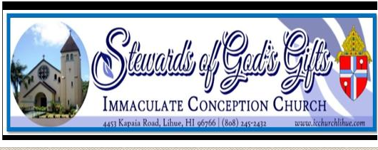
SCHOOL YEAR 2021-2022: EDGE MIDDLE SCHOOL YOUTH MINISTRY 6TH to 8TH GRADE
**Please fill out a separate registration form for each child

THIS REGISTRATION IS FOR: (Check One)
☐ A child who was not in Catechetical classes last year.
☐ A child who was in the Catechetical classes at ICC, Lihue last year.
☐ A child who attended Catechetical classes in a different parish last year.

FAMILY INFORMATION:
Name of the head of the household:
Registered at ICC Parish? Yes☐ No☐If not, please fill out a Parish Census Card found at the back of the Church.
Mailing Address: | City: | Zip:
Family Email:

STUDENT INFORMATION:
Last Name: | FIRST NAME:
Nick Name: | Grade in Fall 2020:
Home/Family Phone: | Gender: ☐ Male ☐ Female
Mother’s Cell: | Father’s Cell:

BIRTH INFORMATION: (As listed on the child’s birth certificate)
Date of Birth: | Place of Birth:
Birth Mother’s Name: | Birth Father’s Name:

BAPTISM INFORMATION: (A copy of Baptismal Certificate is required for new students)
☐ Has NOT been baptized ☐ Has been baptized | Date baptized:
Where? (Name of Parish) | Address:

FIRST COMMUNION INFORMATION:
☐ Has NOT receive 1st Communion ☐ Has received 1st Communion | Date of 1st Communion:
Where? (Name of Parish) | Address:

CONFIRMATION INFORMATION:
☐ Has NOT been Confirmed ☐ Has been Confirmed | Date of Confirmation:
Where? (Name of Parish) | Address:

PARENTAL/GUARDIAN CONSENT AND FAMILY AGREEMENT:
I, _______________________________________, give permission for my child_________________________________ to attend faith formation classes and related activities of Immaculate Conception Church, Lihue, HI, and to receive sacraments (Baptism, First Communion, Reconciliation and Confirmation) at the appropriate ages. I also authorize and give full consent, without limitation or reservation, to this Church, to publish Parish photograph or video in which the above-named student appears while participating in any program associated with Religious Education Ministry.
My child and I agree to follow the rules and standards outlined in the Religious Education Handbook of the Parish.
We are expected to attend Mass every Sunday.

Student Signature: _____________________________________________ Date: _______________

Parent/Guardian Signature: ______________________________________ Date: _______________

