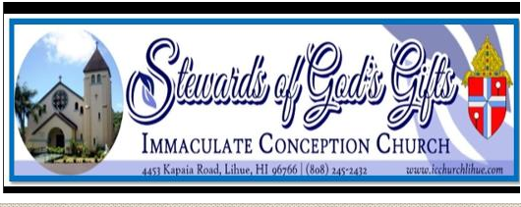
SCHOOL YEAR 2021-2022
KAUAI CATHOLIC CAMPUS MINISTRY
Young Adult Ministry Program
Please Print Clearly:
GENERAL INFORMATION:
Name: | Age:
Date of Birth: | Sex: ☐ Male ☐ Female
Contact Number: | Email:
Course enrolled:

Mailing Address:

Parent/Guardian Name: | Contact Number:

BAPTISM INFORMATION: (A copy of Baptismal Certificate is required for new students)
☐ Has NOT been baptized ☐ Has been baptized | Date baptized:
Where? (Name of Parish) | Address:

FIRST COMMUNION INFORMATION:
☐ Has NOT receive 1st Communion ☐ Has received 1st Communion | Date of 1st Communion:
Where? (Name of Parish) | Address:

CONFIRMATION INFORMATION:
☐ Has NOT been Confirmed ☐ Has been Confirmed | Date of Confirmation:
Where? (Name of Parish) | Address:

CONSENT AND AGREEMENT:
I, _______________________________________, of legal age, wish to join the Kauai Catholic Campus Ministry (Catholic Club). I also authorize and give consent, without limitation or reservation, to this club, to publish photographs and videos in which I appear while participating in any program associated with the Kauai Catholic Campus Ministry (Catholic Club).

Student Signature: _____________________________________________ Date: ________________________________

“I can do all things through Christ who strengthens me.” Philippians 4:13

