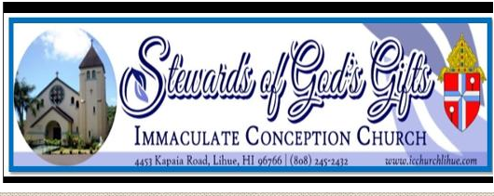
SCHOL YEAR 2022- 2023 PRE K – 5TH GRADE REGISTRATION FOR **Please Fill out a separate registration form for each child
ELEMENTARY
This Registration is for: (Check One)
A child who was not in Catechetical classes last year.
A child who was in the Catechetical classes at ICC, Lihue last year.
A Child who attended Catechetical classes in a different parish last year.
FAMILY INFORMATION
Name of the head of the household _________________________________________________________________
Registered at ICC Parish? YES NO If not, please fill out a Parish Census Card found at the back of the Church.
Street Address _______________________________________ City____________________ ZIP ________________
Family E-mail: ___________________________________
STUDENT INFORMATION:
Last Name: ________________________________________ FIRST NAME: ______________________________
Nickname: ____________________________________ Grade in Fall 2022 _________________________________
Home / Family Phone: _________________________ Gender: Male Female
Mother’s Cell (________) ___________ ___________ Father’s Cell (________) ___________ ________________

BIRTH INFORMATION: (As listed on the child’s birth Certificate)
Date of Birth ___ ___ / ____ ___ / ___ ___ ___ ___ Place of birth _______________________________________
Birth Mother’s Name____________________________Birth Father’s Name: ________________________________

BAPTISM INFORMATION: (a copy of Baptismal Certificate is required for new student)
Has NOT been baptized Has been baptized When? ___ ___ / ___ ___ / ___ ___ ___ ___
Where? ____________________________________ (Name of the Parish) Address________________________________
FIRST COMMUNION INFORMATION:
Has NOT received 1st Communion Has received 1st Communion When? ______________________________
Where? __________________________________ (Name of the Parish) Address_________________________________
CONFIRMATION INFORMATION:
Has not been Confirmed Has been Confirmed When? ___ ___ / ___ ___ / ___ ___ ___ ___
Where? _________________________________________(Name of the Parish) Address___________________________

PARENTAL / GUARDIAN CONSENT AND FAMILY AGREEMENT:
I, _______________________, give permission for my child____________________________ to attend faith formation classes and related activities of Immaculate Conception Church, Lihue, HI, and to receive sacraments (Baptism, First Communion, Reconciliation and Confirmation) at the appropriate ages. I also authorize and give full consent, without limitation or reservation, to this Church, to publish Parish photograph or video in which the above-named student appears while participating in any program associated with Religious Education Ministry.
My child and I agree to follow the rules and standards outlined in the Religious Education Handbook of the Parish.
We are expected to attend Mass every Sunday.

Student Signature: _____________________________________________ Date: _______________
Parent/Guardian Signature: ______________________________________ Date: _______________

