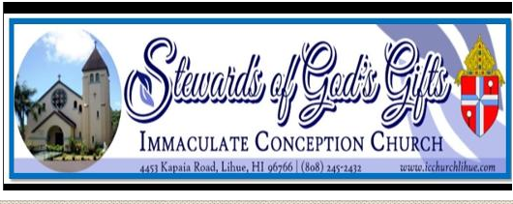
LIFETEEN/JAM- High School Youth Ministry
9TH GRADE - 12TH GRADE
SCHOOL YEAR ____________________ REGISTRATION FORM
**Please Fill out a separate registration form for each child
This Registration is for: (Check One)
A child who was not in Catechetical classes last year.
A child who was in the Catechetical classes at ICC, Lihue last year.
A Child who attended Catechetical classes in a different parish last year.

FAMILY INFORMATION:
Name of the head of the household _______________________________________________________________
Registered at ICC Parish? YES NO If not, please fill out a Parish Census Card found at the back of the Church.
Street Address _______________________________________ City____________________ ZIP ________________
Family E-mail: __________________________________________________________________________________
STUDENT INFORMATION:
Last Name: ________________________________________ FIRST NAME: ______________________________
Nickname: ____________________________________ Grade in Fall 2022 _________________________________
Home / Family Phone: _________________________ Gender: Male Female
Mother’s Cell (________) ___________ ___________ Father’s Cell (________) ___________ ________________
BIRTH INFORMATION: (As listed on the child’s birth Certificate)
Date of Birth ___ ___ / ____ ___ / ___ ___ ___ ___ Place of birth _______________________________________
Birth Mother’s Name____________________________Birth Father’s Name: _________________________________

BAPTISM INFORMATION: (a copy of Baptismal Certificate is required for new student)
Has NOT been baptized Has been baptized When? ___ ___ / ___ ___ / ___ ___ ___ ___
Where? ______________________________ (Name of the Parish) Address________________________________________
FIRST COMMUNION INFORMATION:
Has NOT received 1st Communion Has received 1st Communion When? ___ ___ / ___ ___ / ___ ___ ___ ___
Where? _______________________________ (Name of the Parish) Address__________________________________________
CONFIRMATION INFORMATION:
Has not been Confirmed Has been Confirmed When? ___ ___ / ___ ___ / ___ ___ ___ ___
Where? _________________________________________(Name of the Parish) Address____________________________

PARENTAL /GUARDIAN CONSENT AND FAMILY AGREEMENT:
I, _______________________, give permission for my child____________________________ to attend faith formation classes and related activities of Immaculate Conception Church, Lihue, HI, and to receive sacraments (Baptism, First Communion, Reconciliation and Confirmation) at the appropriate ages. I also authorize and give full consent, without limitation or reservation, to this Church, to publish Parish photograph or video in which the above-named student appears while participating in any program associated with Religious Education Ministry.
My child and I agree to follow the rules and standards outlined in the Religious Education Handbook of the Parish.
We are expected to attend Mass every Sunday.

Student Signature: _____________________________________________ Date: _______________

Parent/Guardian Signature: ______________________________________ Date: _______________

