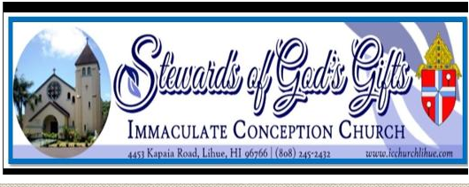
EDGE- Middle School Youth Ministry
6TH GRADE - 8TH GRADE
SCHOOL YEAR 2022-2023 REGISTRATION FORM
**Please Fill out a separate registration form for each child This Registration is for: (Check One)
A child who was not in Catechetical classes last year.
A child who was in the Catechetical classes at ICC, Lihue last year.
A Child who attended Catechetical classes in a different parish last year.

FAMILY INFORMATION
Name of the head of the household ________________________________________________________________
Registered at ICC Parish? YES NO If not, please fill out a Parish Census Card found at the back of the Church.
Street Address _______________________________________ City____________________ ZIP ________________
Family E-mail: ___________________________________
STUDENT INFORMATION:
Last Name: ________________________________________ FIRST NAME: ______________________________
Nickname: ____________________________________ Grade in Fall 2022 _________________________________
Home / Family Phone: _________________________ Gender: Male Female
Mother’s Cell (________) ___________ ___________ Father’s Cell (________) ___________ ________________
BIRTH INFORMATION: (As listed on the child’s birth Certificate)
Date of Birth ___ ___ / ____ ___ / ___ ___ ___ ___ Place of birth _______________________________________
Birth Mother’s Name____________________________Birth Father’s Name: ________________________________

BAPTISM INFORMATION: (a copy of Baptismal Certificate is required for new student)
Has NOT been baptized Has been baptized When? ___ ___ / ___ ___ / ___ ___ ___ ___
Where? ______________________________ (Name of the Parish) Address________________________________________
FIRST COMMUNION INFORMATION:
Has NOT received 1st Communion Has received 1st Communion When? ___ ___ / ___ ___ / ___ ___ ___ ___
Where? _______________________________ (Name of the Parish) Address_______________________________________
CONFIRMATION INFORMATION:
Has not been Confirmed Has been Confirmed When? ___ ___ / ___ ___ / ___ ___ ___ ___
Where? _________________________________________(Name of the Parish) Address___________________________

PARENTAL / GUARDIAN CONSENT AND FAMILY AGREEMENT:
I, _______________________, give permission for my child____________________________ to attend faith formation classes and related activities of Immaculate Conception Church, Lihue, HI, and to receive sacraments (Baptism, First Communion, Reconciliation and Confirmation) at the appropriate ages. I also authorize and give full consent, without limitation or reservation, to this Church, to publish Parish photograph or video in which the above named student appears while participating in any program associated with Religious Education Ministry.
My child and I agree to follow the rules and standards outlined in the Religious Education Handbook of the Parish. We are expected to attend Mass every Sunday.

Student Signature: _____________________________________________ Date: _______________

Parent/Guardian Signature: ______________________________________ Date: ________________

